**Question 34 [from 2016 Sem I paper WATP] (13 marks)**

1. The nervous system has several different subdivisions which have quite specific functions. Using the table below, state one functional difference between the following parts of the nervous system.

(3 marks)

|  |  |
| --- | --- |
| **Two systems to compare** | **Main difference** |
| Afferent division vs efferent division of the peripheral nervous system |  |
| Central nervous system compared to the peripheral nervous system |  |
| Somatic sensory nervous system compared to the visceral sensory nervous system |  |

The diagram below is of the human brain.

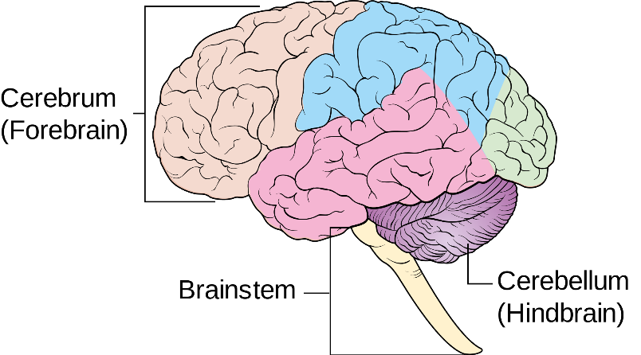

1. On the diagram, label the following areas: (2 marks)
2. the occipital lobe.
3. the medulla oblongata.
4. The brain and the spinal cord are very delicate and, as they are vital to human survival, they must be protected. One structure that provides protection for these two parts are the meninges.
5. Describe the general structure of the meninges. (1 mark)

______________________________________________________________________________________________________________________________________

1. Explain the role of the cerebrospinal fluid. (2 marks)

____________________________________________________________________________________________________________________________________________________________________________________________________________________________________________________________________________

d) The human brain is divided up into several sections, each with its own set of specific functions. Complete the table below by summarising ONE function of each area shown. (3 marks)

|  |  |
| --- | --- |
| **Structure** | **Function** |
| Cerebral Cortex |  |
| Hypothalamus |  |
| Medulla oblongata |  |

1. During a mining accident, a man received substantial damage to his cerebellum when a metal pipe hit him from behind.

Describe two symptoms the man might experience as a result of this damage. (2 marks)

________________________________________________________________________________________________________________________________________________________________________________________________________________________________________________________________________________________________________________________________________________________________________

**Question 34 [from 2016 Sem II Exam] (17 marks)**

The transmission of nerve impulses occurs via electro-chemical changes that occur where the impulse is propagated and transferred.

1. Some anticonvulsants, such as Valium (diazepam), work by allowing more chloride ions to enter a patient’s neurons, making the resting potential more negative. Explain how this would affect the ability of the neuron to generate an action potential. (2 marks)

_________________________________________________________________________

__________________________________________________________________________________________________________________________________________________

__________________________________________________________________________________________________________________________________________________

1. The disease Multiple Sclerosis (MS) damages the myelin sheath and scars the nerve cell membrane. Using your knowledge of nerve cells, explain why MS sufferers experience uncontrollable tremors. (2 marks)

_________________________________________________________________________

__________________________________________________________________________________________________________________________________________________

__________________________________________________________________________________________________________________________________________________

1. The nervous system is composed of two main divisions (Central Nervous System or CNS, and Peripheral Nervous System or PNS) and has three major functions. Identify which division and function of the nervous system are associated with the following by placing a tick in the appropriate boxes. (4 marks)

|  |  |  |  |  |  |
| --- | --- | --- | --- | --- | --- |
|  | **Division of the Nervous System** | | **Nervous System Function** | | |
|  | **CNS** | **PNS** | **Sensory** | **Integration** | **Motor** |
| **Visual Cortex** |  |  |  |  |  |
| **Secretion from glands** |  |  |  |  |  |

1. The CNS contains both grey and white matter. Name the part of the brain which connects the two hemispheres, and describe the type of matter from which it is made. (3 marks)

_________________________________________________________________________

__________________________________________________________________________________________________________________________________________________

__________________________________________________________________________________________________________________________________________________

1. Due to the delicate and vital nature of the brain and spinal cord, these parts of the body are heavily protected by various structures. Name **one (1)** of the structures and explain how it protects the CNS. (3 marks)

_________________________________________________________________________

__________________________________________________________________________________________________________________________________________________

__________________________________________________________________________________________________________________________________________________

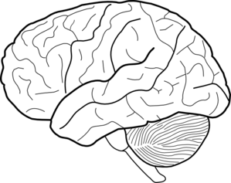

B

A

1. Referring to the diagram above, briefly explain how parts A and B work together to enable a skier to glide smoothly across the snow. (3 marks)

_________________________________________________________________________

____________________________________________________________________________________________________________________________________________________________________________________________________________________________________________________________________________________________________